INT-213 REPORT

HUMAN COMPUTER INTERACTION

SUBMITTED BY:

SALONI RAJPUT

SECTION: K1640

ROLL NUMBER: A11

REGISTRATION NUMBER: 11610748

GITHUB LINK: <https://github.com/202saloni/saloni_a11_k1640.git>

**EVALUATION 1:**

1: Describe the significance of project.

The project is an online website that provides information about blood donation camps. The website provides a detailed information about how to organize donation camp and about blood , its main objectives and different events that are organised by the camp . The website is divided into 6 pages : Home , AboutUs , About Blood , Rise a Request , Get involved and Contact . The home page provides the images of previous blood camps organized and information about how we can solve the problem of blood shortage. AboutUs page provides the information about the blood donation camp, awareness sessions and about our helpline. About Blood page gives a detailed information about human blood, hemoglobin and blood groups. Rise a request page provides the a form to users who want to donate blood .Get Involved page provides the information about the upcoming events that are being held at the camp and some information given to the users who want organise their donating camps . Contact page provide a form to user . The page provides the complete information about the camp and also has a query form that helps the user to get linked to the donation camp.

2: Compare the approach used in project with the existing approaches.

There are a number of similar websites that are already present. The website includes simple design that is very easy to understand and is a good balance of text and graphics. The color combination of the pages is also very good and the content is not confusing. The site provides the complete information about the content present in it. Unlike other websites this website provides brief information about the human blood, blood donation camps, how to reduce the storage of blood and how to organize a camp. The project site also provides the information about the events held at the place. It also provides an opportunity to donate blood and save a life.

3: Is there any innovative method you have used toward the project?

The project is designed mainly using HTML and CSS. In addition to these two languages JAVA SCRIPT is used to provide animation and dynamics to the pages. The pages are designed in the form of divisions that provide the content in the form of blocks that help in distinguishing the different blocks of data easily. The project also provides the detailed information about human blood, blood groups, how to donate and camp organization at any place.

**EVALUATION 2:**

1: Will different sections of your site require different designs, layouts or coloring?

Yes the different sections of my website requires different designs , layouts and coloring . In some pages , the division layout is used and in some pages the form layout is used . The color scheme is also different in different pages. The idea was to create a colourful website with decent use of colors.

2: What kind of layout you employed in project?

There are different layouts used in the website. The main layouts are tables and form layout.

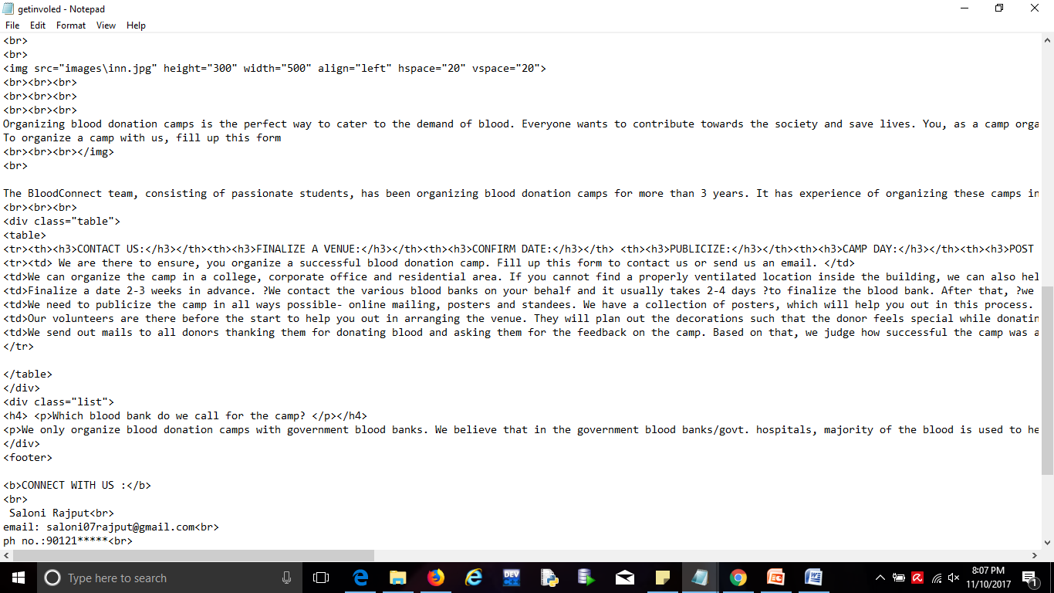

3: What are the different kinds of explicit validations applied in the project?

Different kinds of explicit validation are used in this website. Validation like required data and

invalidated data are used in website. Secure storage and encryption is used to protect a user’s secret from others. 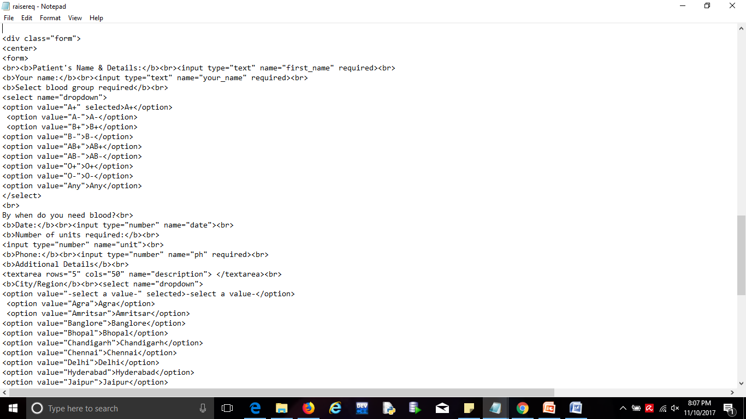

4: What kind of security technique is employed in the project?

This project is a public website so that anyone can access this website.

5: Does the content sufficient the purpose of website in terms of functional requirements?

The content in the website fulfills all the functional requirements of the website. It provides all the information about every section of the project with pictorial references thus helping in better understanding .

6: Have you employed any function for the modularization of web pages?

The website is designed in a single module.

7: Have you used GitHub repository to maintain different revisions of the project?

Yes I have used GitHub repositary to maintain revisions of the projects. The snapshot of the links of the GitHub repositary are provided below:

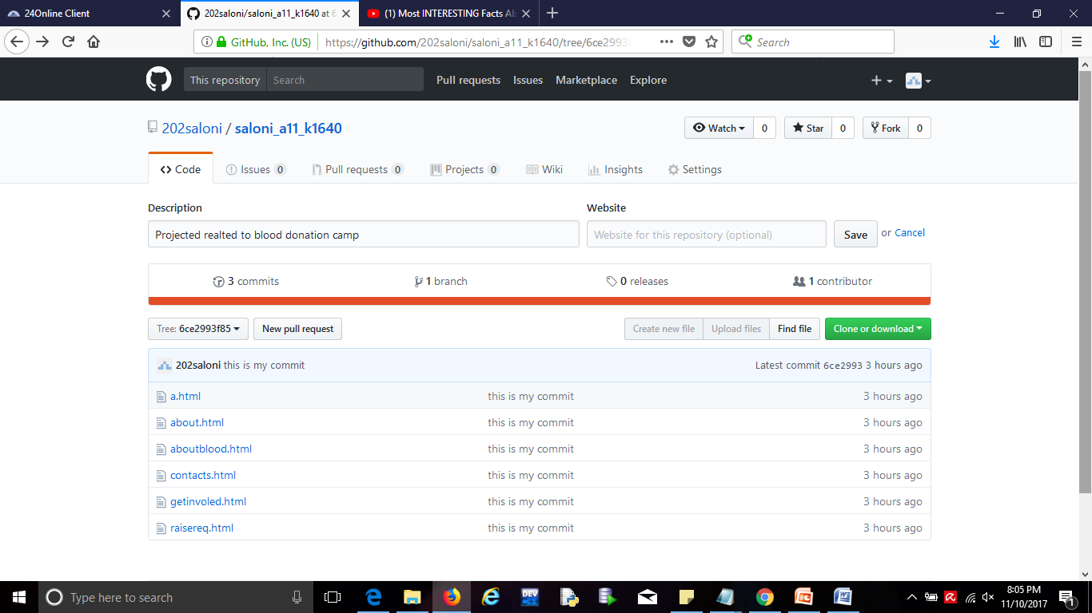

**HOME PAGE**

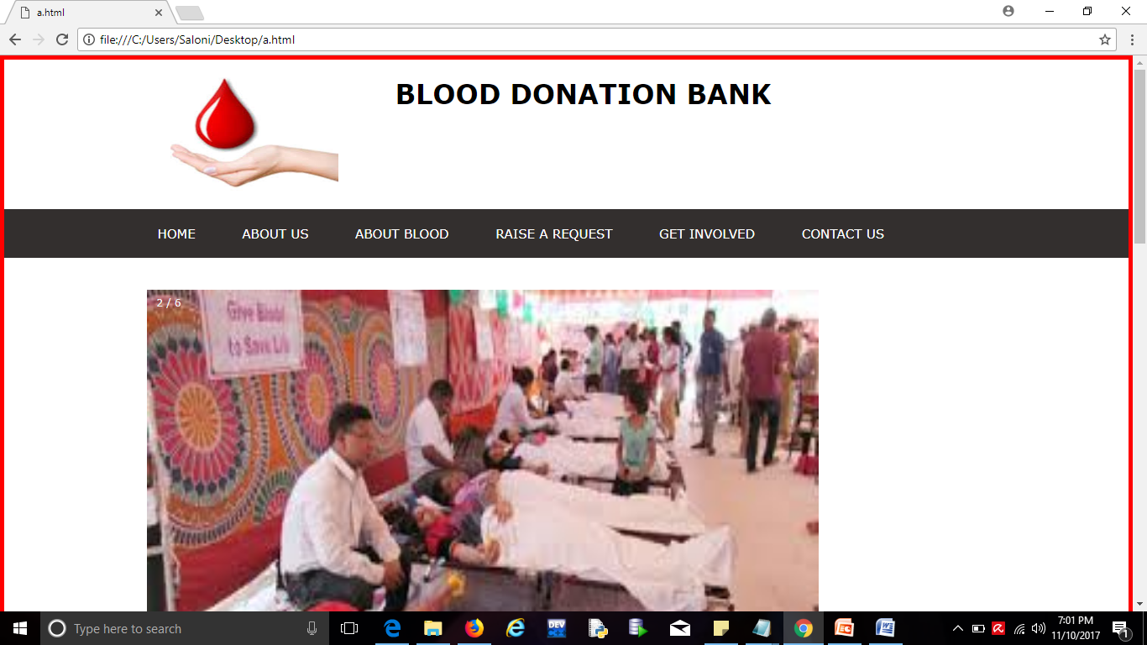

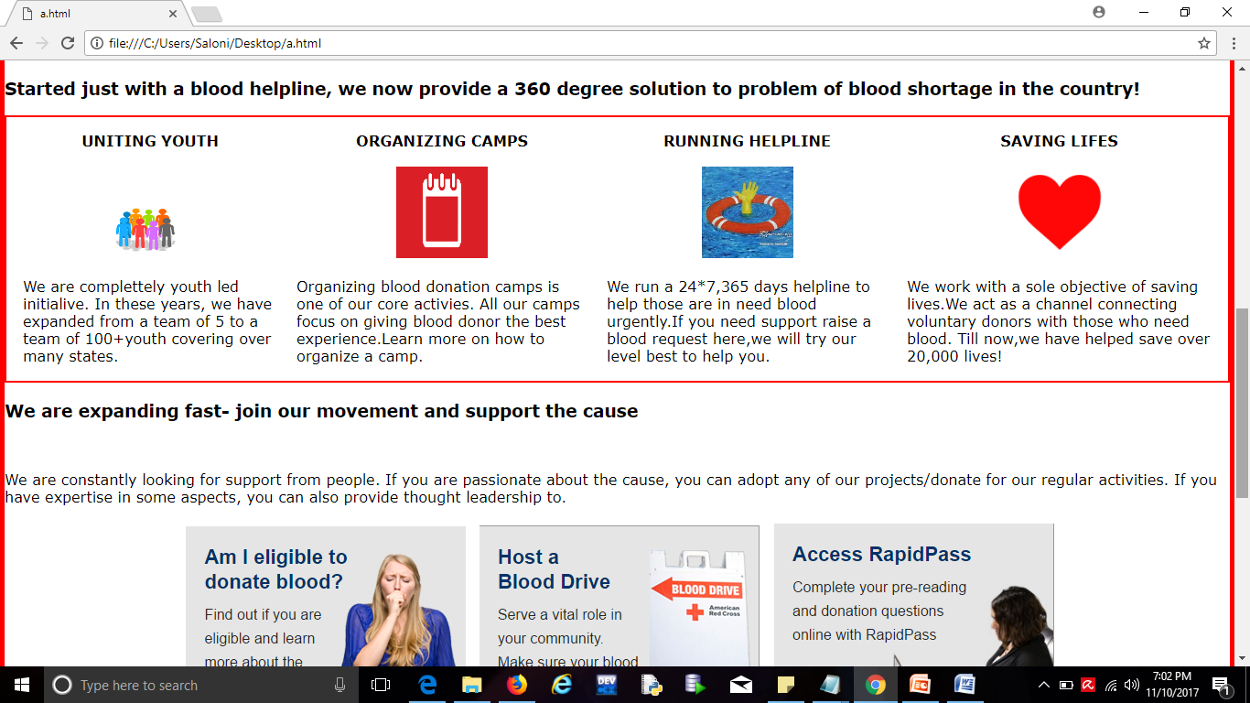

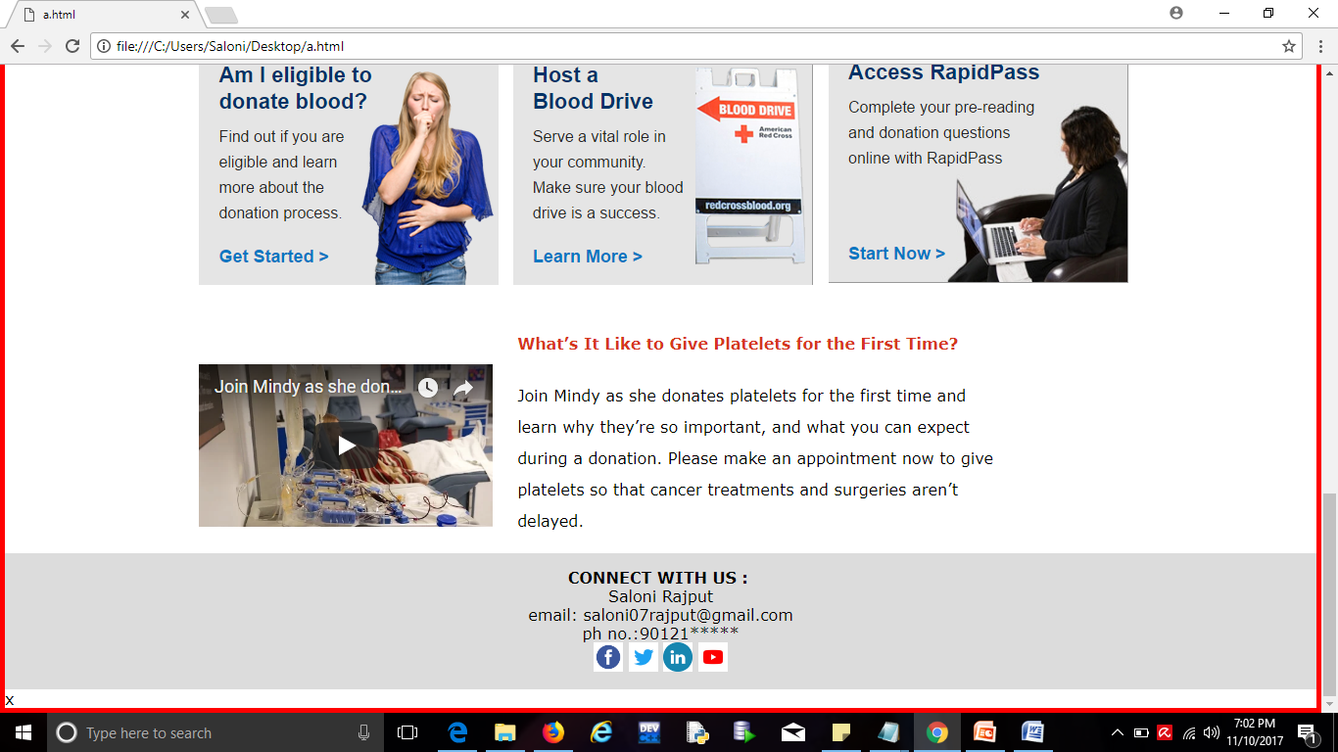

This page consist information about the website. How to organize camp, helpline and how to united together reduse the problem of blood storage. This page also consist a small video for the first time donor and information about us

**ABOUT US:**

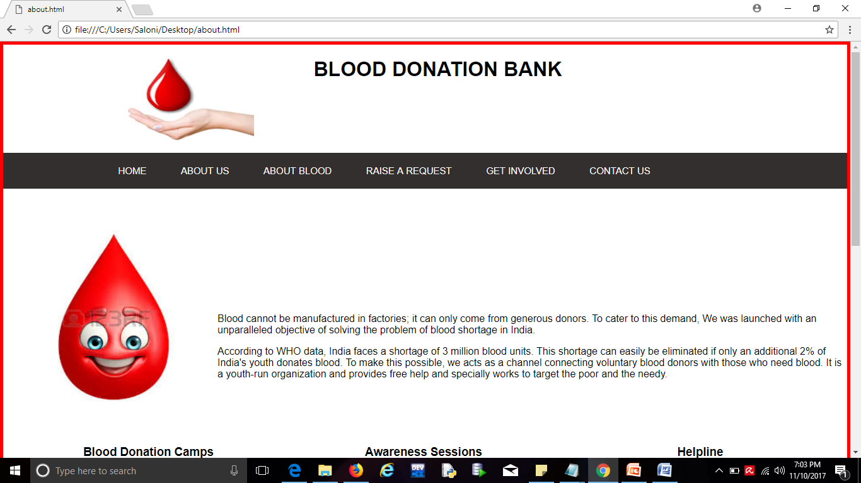

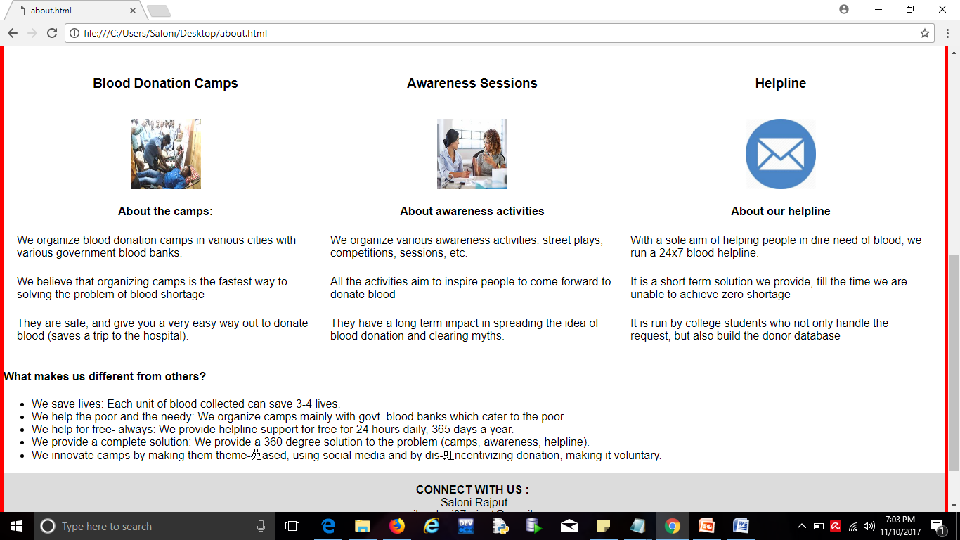

This page consist the information about us. How we organize blood donation camps in various cities and various awareness activities street plays, competition, sessions etc. It also consist information about our helpline.

**RAISE A REQUEST:**

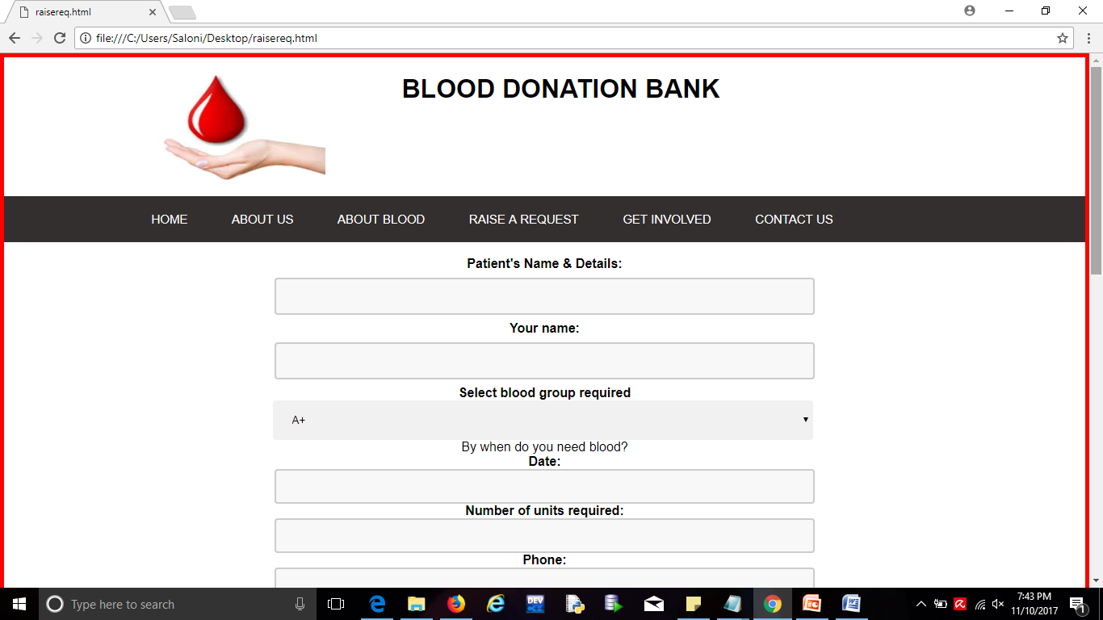

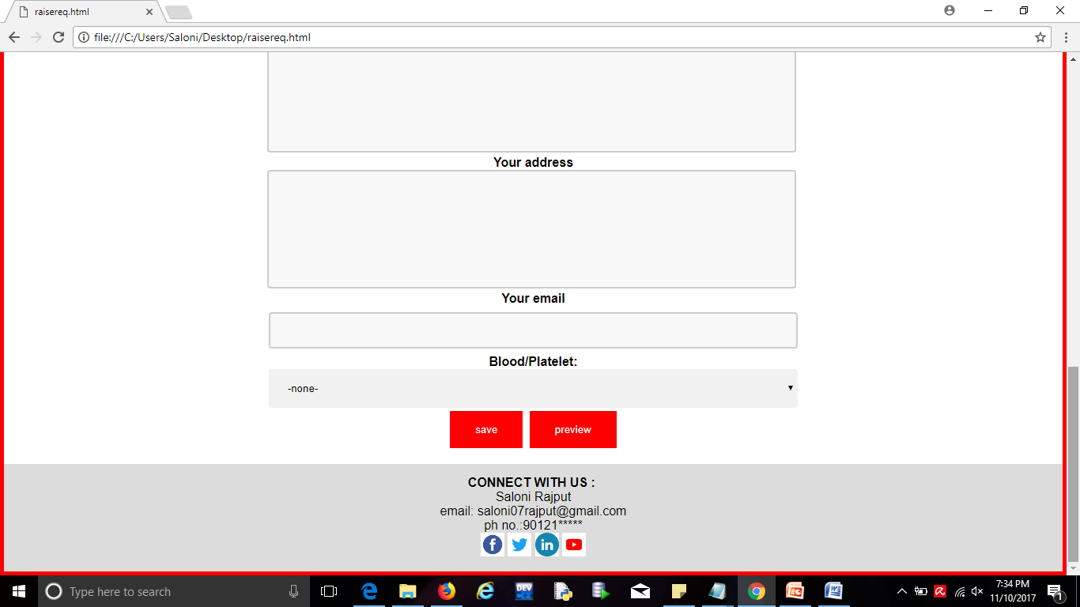

This page consist a form for patients. Persons detail like blood group, phone number, email, address , hospital in which they can donate blood easily etc.

**ABOUT BLOOD:**

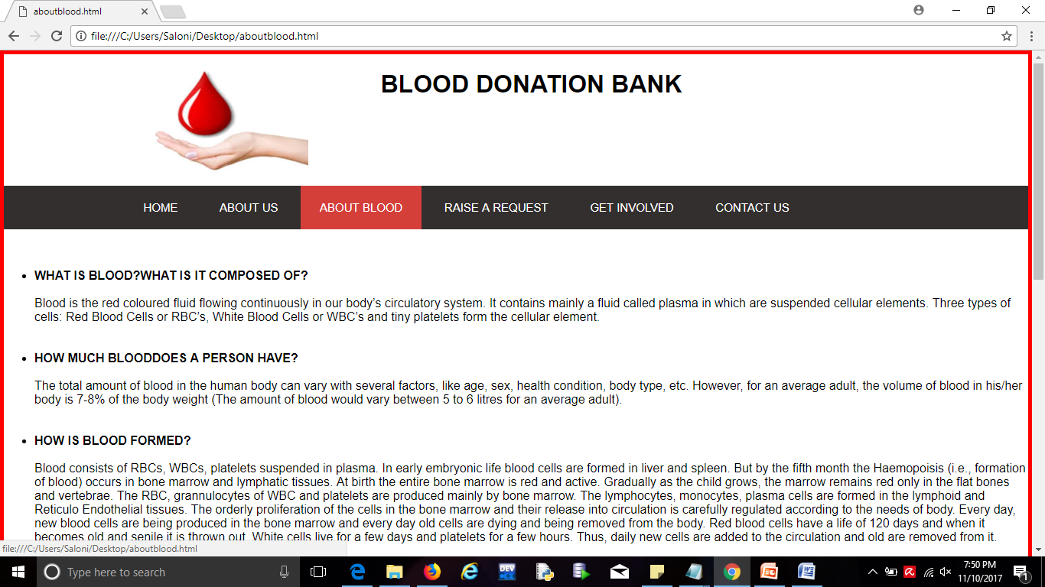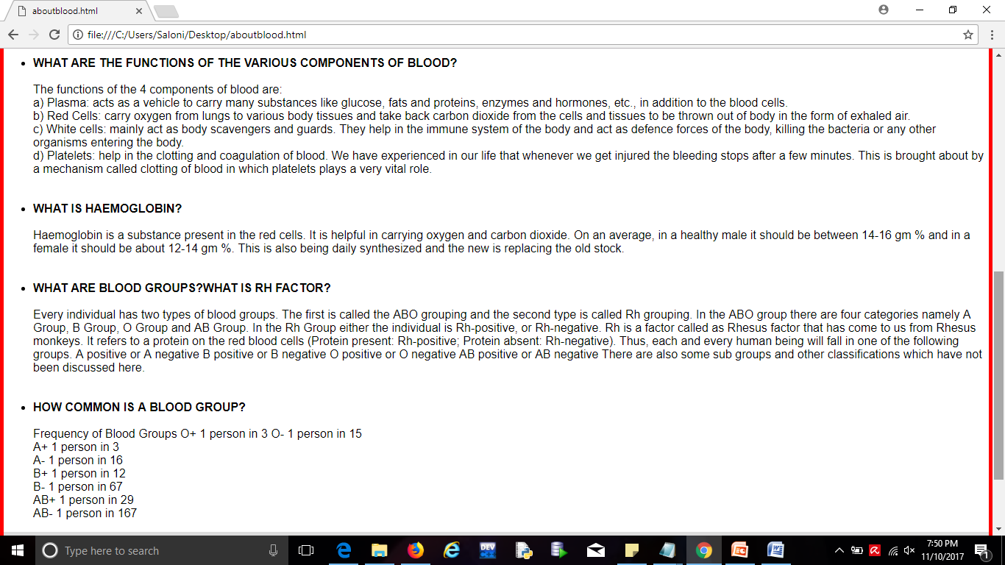

This page consist the information about human blood. The function of various components of blood, hemoglobin, blood group and their factor.

**GET INVOLVED:**

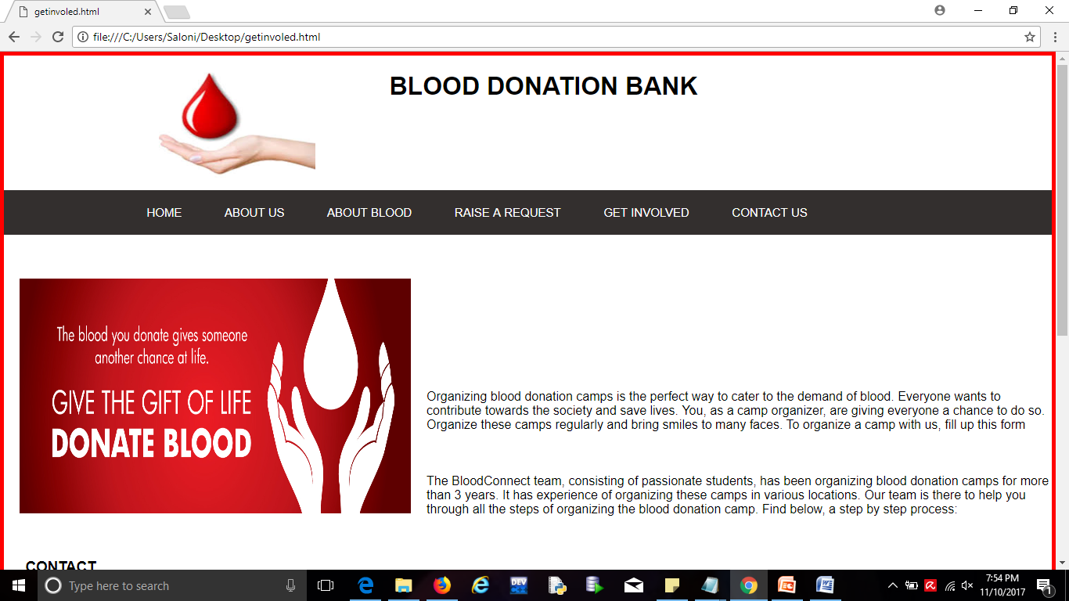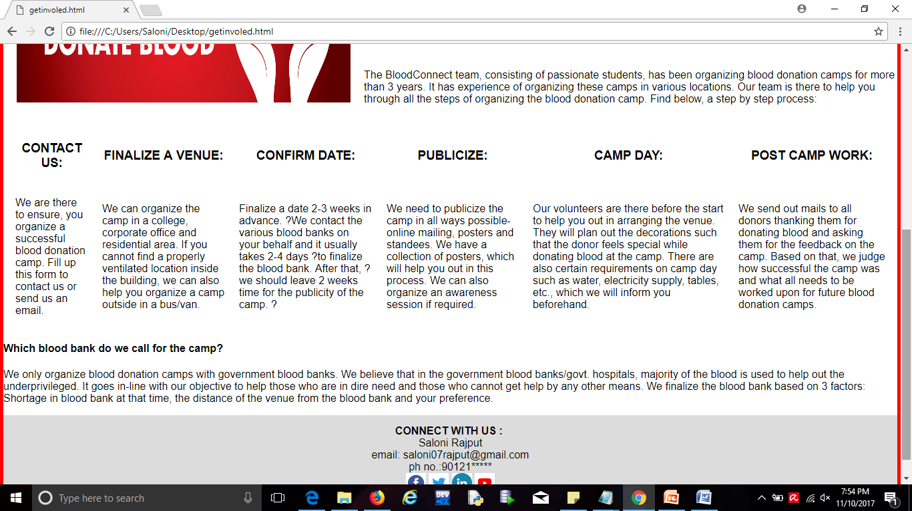

This page consist the information about the steps to follow if you want to organize a blood camp near you.

**CONTACT US:**

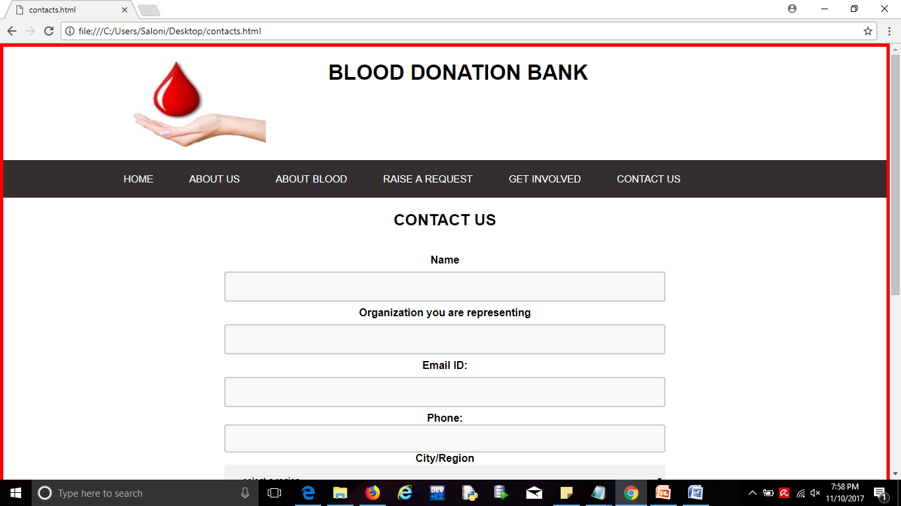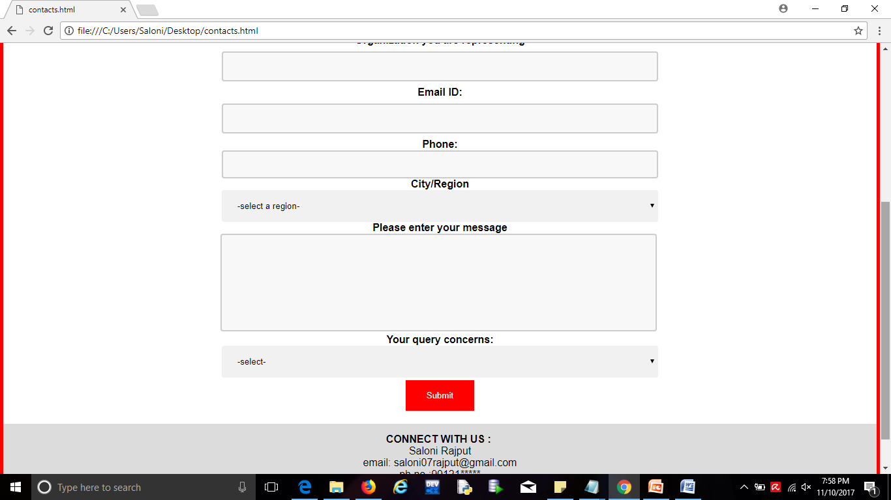

This contact us webpage consist a form. Threw which anyone can indirectly contact us and directly threw by mails and call.